People Profile
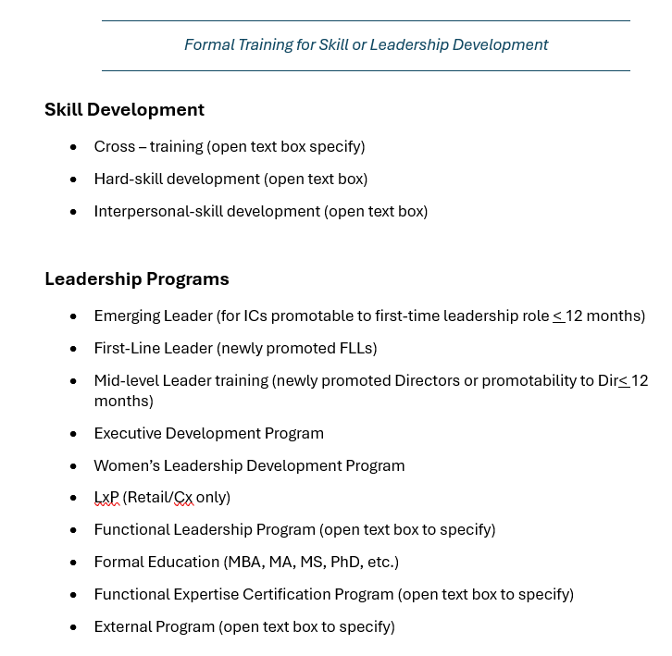
- Create Picklist
- Object Definition
- Provide permissions
- Manage Configuration UI
- Configure People Profile

Manage Configuration UI > Create New >Select base Object (select from dropdown the base object)
Edit Properties : Select Layout : Grid

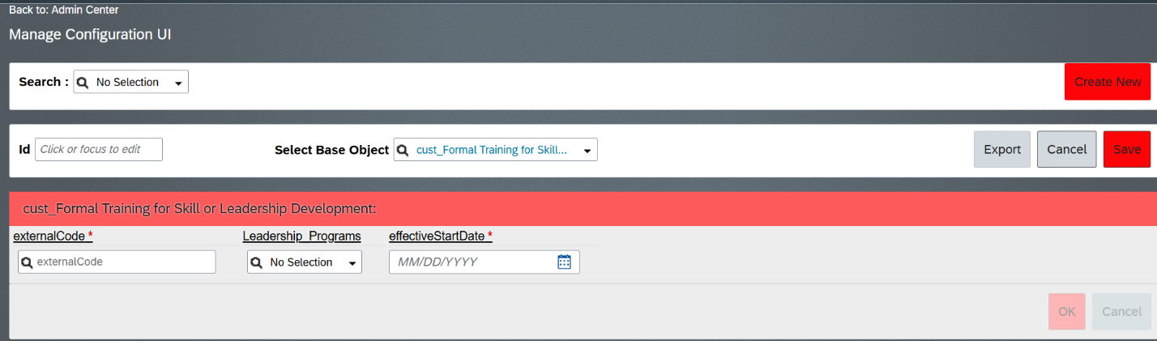

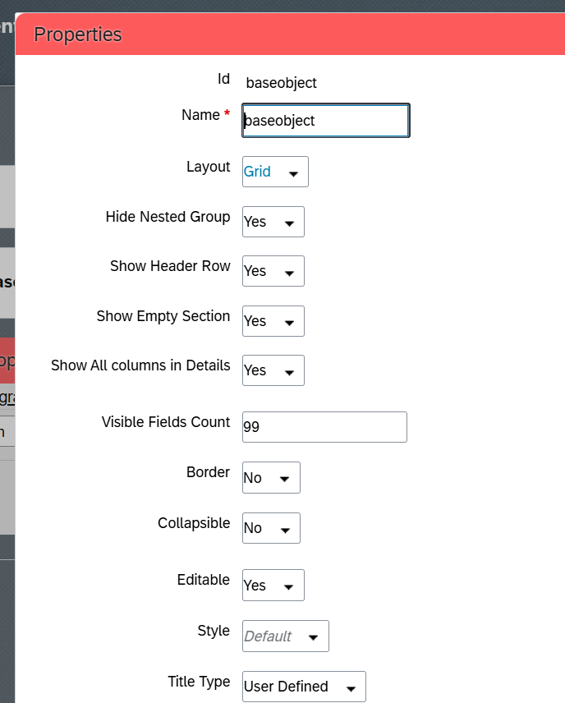

Manage Permission Roles > Select FL GLOBAL ADMINISTRATOR > Edit > Next > Miscellaneous Permissions

Look for the Object to be permissioned
Provide permission for every action for Admins
Next
Save

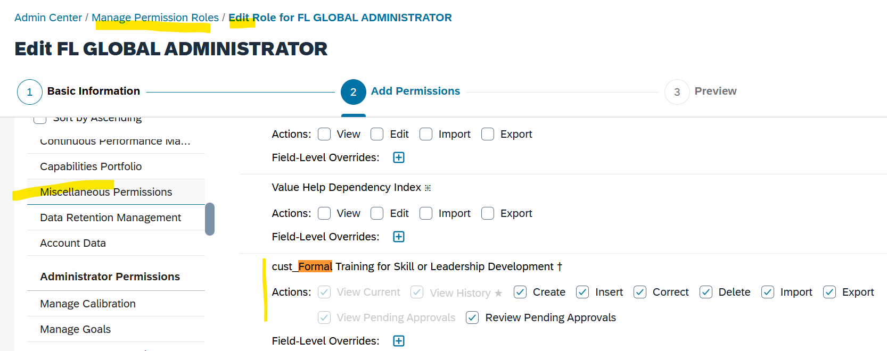

Add Text box
Configure Object Definition

